Artificial intelligence (lab)
Task 4

Submitted to: Sir Rasikh Ali

Submitted by
Name | Roll no | Section
Zara Asghar | Su92-bssem-s25-050 | BSSEM 4(A)

Part 1: Manual A* Calculations and Implementation

Explanation
A* is an informed search algorithm that finds a low-cost path using the formula \(f(n)=g(n)+h(n)\). Here, \(g(n)\) is the actual cost from the start, and \(h(n)\) is the estimated remaining cost. In this task, A* finds a route from S to G and displays the values of \(g\), \(h\) and \(f\) for each selected node.
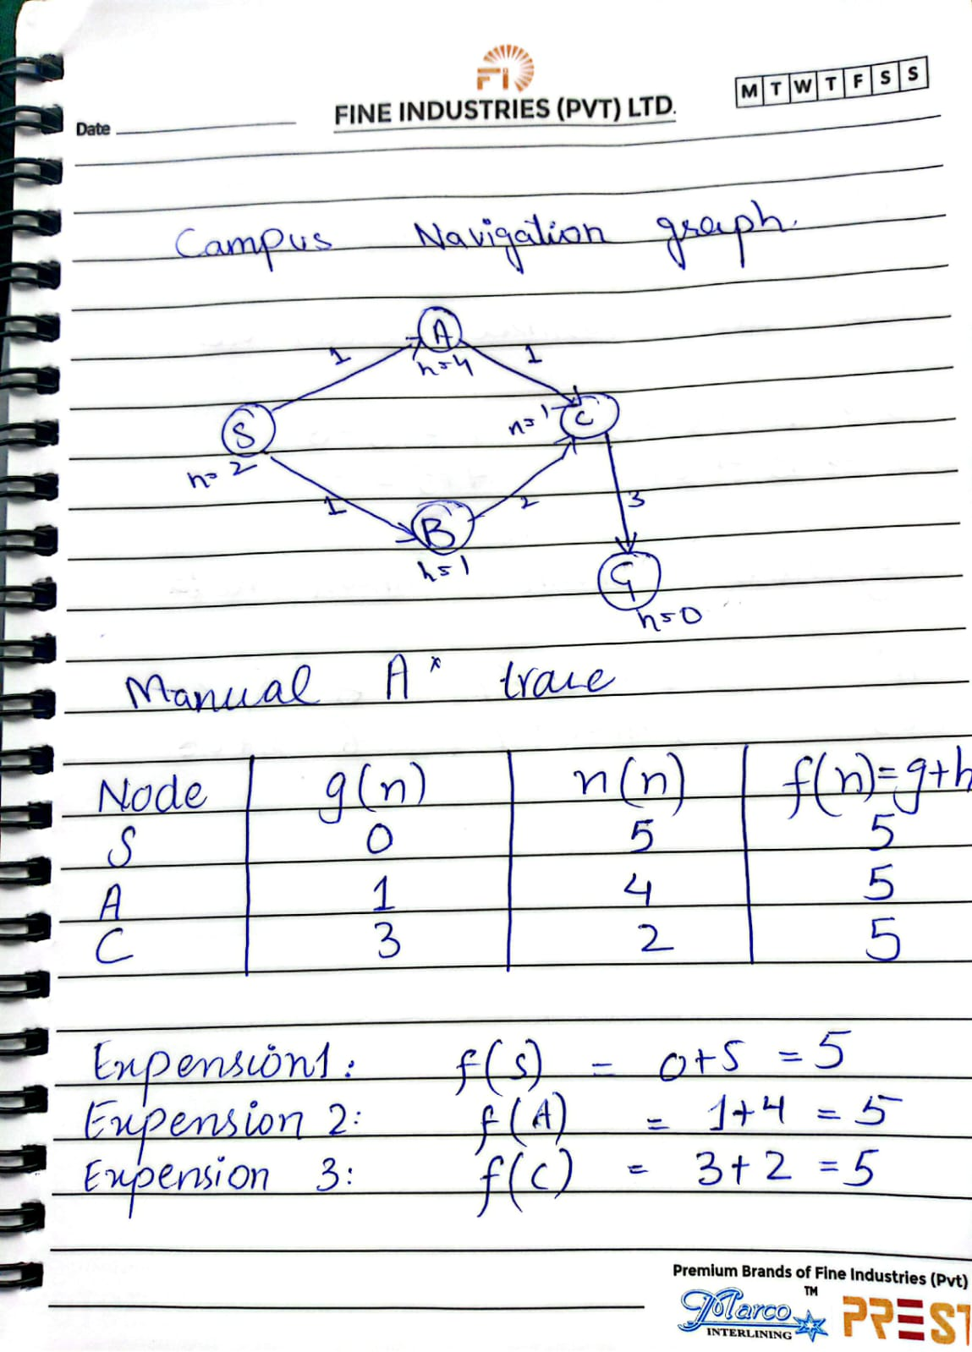

Part 2: Comparison of A* and Uniform Cost Search (UCS)

Explanation
Uniform Cost Search selects the node with the lowest actual path cost. It can be implemented using A* by setting every heuristic value to zero. In this task, both algorithms use the same graph and endpoints so their results can be compared fairly.
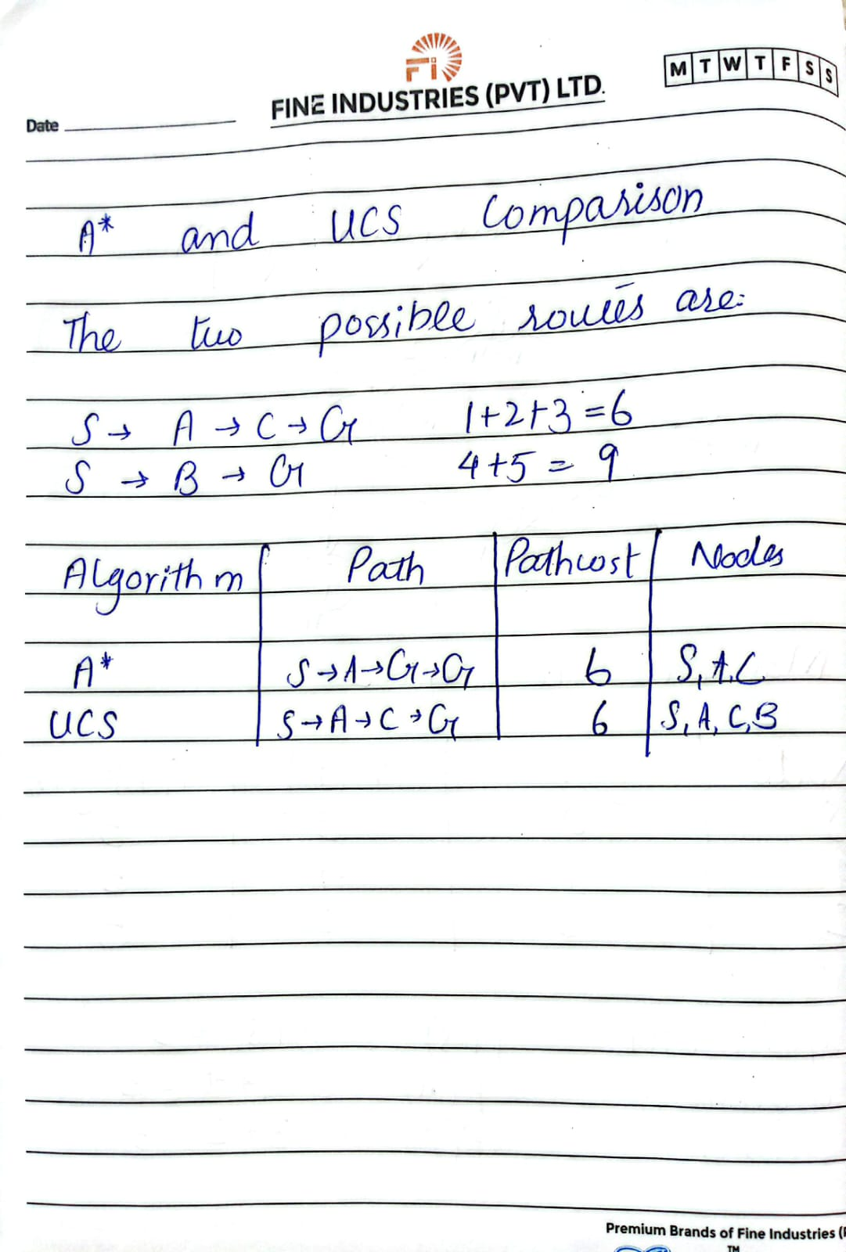
Part 3:

Explanation
A heuristic is admissible when it does not overestimate the true remaining cost. In this task, the heuristic value of node C is changed from 2 to 10. Since the actual remaining cost from C to G is 3, this modification makes the heuristic an overestimate. The experiment shows how this can affect the path returned by A*.

